Welcome to the sixth and final segment of Getting Started with Google Suite. By the end of this segment, you should be able to explain how to access Google Forms, be able to demonstrate the basics of how to use Google Forms, be able to demonstrate how to access the data Google Forms collects, and be able to explain how and why you would want to download Google Forms.

**How to access Google Forms?**

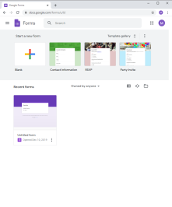There are two ways to access Google Forms depending on what you are looking for. The first is to go to Google Forms. To do this: Open Chrome, click in the address bar at the top and type in “Google Forms” and hit enter. In the search results that come up click on the second link that says “Sign-In”. Using this route will allow you to easily access the template gallery and see what the templates look like without taking an extra step. The downside is that it will auto-create the file in your main Google Drive, which can cause file chaos if you do not take time to organize it.

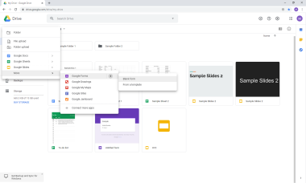The second way to access Google Forms is to go through Google Drive. To do this: Open Chrome, click in the address bar at the top and type in “Google Drive” and hit enter. Click on the second ink that says “Sign-in” which will take you to your Drive. Then click on the “New” button, hover over the “More”, go over to Google Forms, go over to the right arrow and choose between either a “Blank Document” or “From a Template”. Using this route will allow you to create the form in the folder where you want it to be, in turn keeping things organized. It also allows you to access the template gallery but does take an extra step with being able to view and choose the one you want to use.

**How to get started with Google Forms**

Google Forms is its own software; the closest thing that it could be compared to it is Survey Monkey and there are fundamental differences there. So everyone learns Google Forms without any real advantages from working with past software. Good news is it’s easy to learn the basics.

By the end of this section you should know how to rename a file, be able to demonstrate the following: how to change the question type, how to add questions, how to insert an images and video, how to add another section, how to preview what the form will look like to those taking it, and explain how to send the form out to those needing to take it.

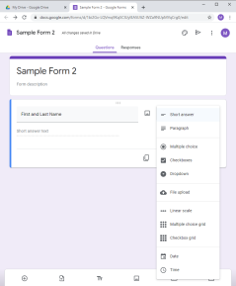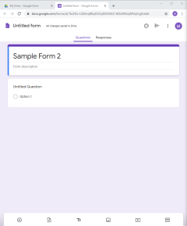To get started go ahead an open a blank Google Form and click where it says “Untitled Form” right above Form description and type in a tile for the form. Then click up on the top where it says “Untitled form” and it will prefill in the file name with the title you just gave the form.

The form has the first question already generation and set to a multiple choice question type. If you go ahead and type a question in, say like “First and Last Name” you will notice that Google Forms auto changes the question type to a short answer. It will attempt to match the text in the question field to the best question type. If it does a good job of matching or you just want to change it to another question type you can do so by clicking on the down arrow on the right hand side of the screen next to “Short Answer.” Doing so opens a drop down menu that shows the different question styles available. The most common are multiple choice, short answer, linear scale and checkboxes. Linear scale is the question type you typically see on surveys when you are asked to rank something between best and worse. Checkboxes allows the responder to choose more than one answer to the question. Other question options are dropdown, file upload, multiple choice grid, checkbox grid, date, and time.

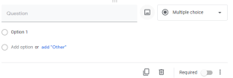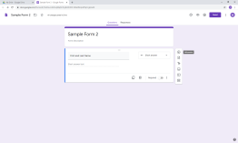No survey, test, or quiz is only one question long so let’s cover how to add more questions. You will notice over on the right-hand side of the first question there is a toolbar with six options on it. The first two focus on questions. The plus in the circle will allow you to add another question to the form. The paper with a right arrow on it would allow you to import questions from another form. Let’s go ahead and just add another question and skip importing questions for now.

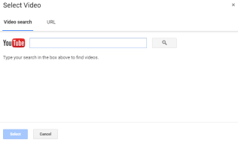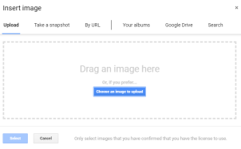Questions and answers in Google Forms do not always have to be text you can add an image to either the question field or the answer field. To do this all you have to do is click on the image icon. To insert one in the question field hover your mouse over the blank space to the right of the question field and to the left of the question type field. You will notice a mountain icon appear, clicking this will open a pop-up window which will allow you to either upload an image from your computer or search the web for one. To insert an image as an answer choice move you mouse down to where it says option 1 and you will notice the image icon appears on the right side. Video cannot be added as a question but it can be added as a new segment, to do so go back to the toolbar on the right side of the question and click on the play button. This will cause a pop-up window to appear allowing you to search YouTube for the content you would like to insert.

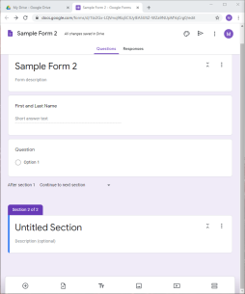You can also use the question toolbar to add another section to the form. Generally you would do this to make it so that there is not an overwhelming amount of questions on the screen. You would just click on the equal sign, which automatically adds a new section. Any questions created after a section will appear in that section. When the form is taken all questions of a section will be displayed on a screen, to move to the next section respondents would have to click on the next button.

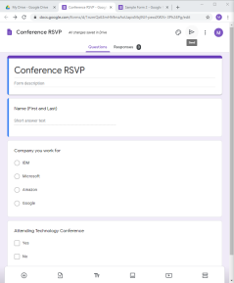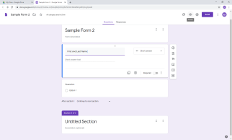Next let’s take a look at what the respondent would see if we sent the form out as it is now. To do this click on the eye icon that is up in the top right-hand corner. Notice how there is a next button on the bottom, clicking this moves us to our second section we added. Since we did not add anything after the second section our only options here is to either go back or to submit our responses. To end the preview close the tab.

Once you have formatted and entered the content you want in your form it’s time to send it out and get some responses. You have two options of how to do this. The easiest, in my option, is to click on the address bar up on the top, copy the address for the form, paste it into an email addressed to those that need to fill it out, and then remove the /edit at the end of the address. The other option is to allow Google Forms to handle the distribution. To do this click on the “send” button up in the top right-hand corner, this will open an pop-up window that is set to auto-generate emails all you have to do is enter in the email, edit the pre-generated message, and then click send. This is a lot like the first method except Google Forms does not have access to your email lists if your company runs through Outlook.

There is still a lot to learn when it comes to Google Forms but that should be enough to get you started with creating forms and collecting information.

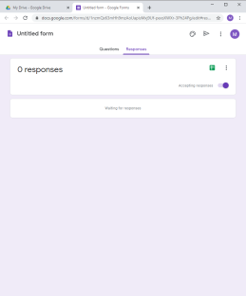 **How to access the data Google Forms collects**

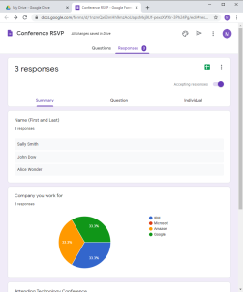There are two ways to access the data that your Google Form collected. The first is to go to your Form file and click on the responses tab up at the top. Scrolling down will show you how many responses that you have received and give you three options, straight from the Google Form, for being able to see data. The first which is auto selected is the summary of all the responses by questions. Google Forms does its best to auto select the easiest way to display the data. Clicking on “Question” up at the top will allow you to see the responses based on each question. Clicking on “Individual” up at the top will allow you to look at each individual submission.

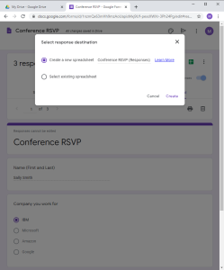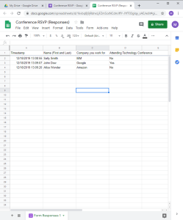The other way to access the data is to go to your form, click on the responses tab up at the top, then click on the green square. This will cause a pop-up window to appear asking you to “Create a New Spreadsheet” or to “Select Existing Spreadsheet”. I generally suggest that you create a new spreadsheet. It will take a moment to generate the spreadsheet, it takes longer with the more responses you have. Once the spreadsheet opens you can see all of your data. The good thing about exporting the data to a Google Sheet is that it will allow you to manipulate the data and with a few step you can create the same visuals that Google Forms was using to display the data.

**How and why you might want to download Google Forms**

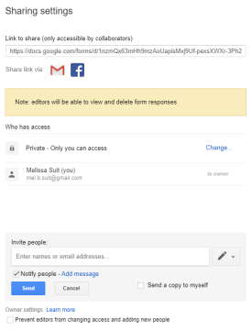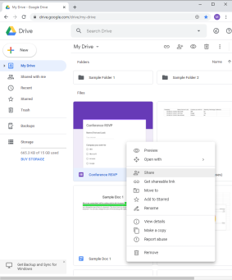Google Forms is completely different to all the other Google creative applications that we have covered so far. It cannot be worked with offline but you can download a copy of the form if you need to. The only real reason to do this is if you know you will be losing access to your Google Account that the forms were created on. WARNING - make sure that what you have created and want to take with you if you are leaving a position is not owned by the company or protected by client confidentiality.

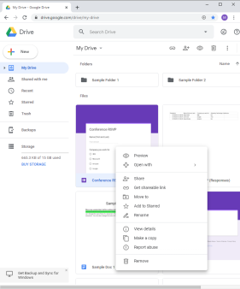Once that is done you have two options. The first is that you can share the form with another Google account that you have, and then with some back and forth, transfer ownership of the file. You may run into company issues if your company has a special network that Google run through, most school systems do. If you want to try this method – locate the file in your Google Drive, right click it, and click “Share.” This will open a pop-up window which has an invite people down at the bottom. Type in the email address of your second Google account, unclick the “Notify People” box, and then hit “Ok”. You may have another pop-up box asking if you really do not want to send a notification and warning you that the person will have to log-in before realizing that they have had a file shared with them. This is fine since it’s you sharing with you. Then back in the original pop-up window you will see that your second account has been added. Click on the arrow next to the pencil and then click “Is Owner”. This in turn transfers ownership of the file allowing your other account full access. This method can be tricky and difficult but is a time saver if you can get it to work.

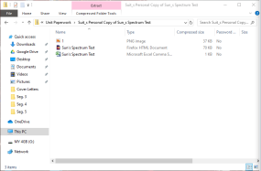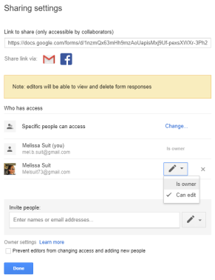The second method which is to download a copy of the Google Form is guaranteed to work but will require you to rebuild the Google Form on your new account. Open your Google Drive. The only fiddly part of this method is that you cannot download just a Google Form; the option is just not there. There are two work arounds for this. The first is to just select another file (Doc, Sheet, or a Slide) by holding down the control button and clicking on it after you have clicked on the form which will get the download option to pop up when you right click. Or just click and drag all of your forms into a folder. Then right click on the folder and select download. No matter which method you use you will get a pop-up box in the bottom right-hand corner showing your progress and once the download has completed a Folder will pop-up in the bottom left hand corner. Click on the folder or the files that you downloaded and drag the files to a place where you will be able to find them again. You will notice that the form files have downloaded in a folder that is zipped. When you go to work with these files again all you need to do is click on the zipped folder, and then find the HTML Document located in the folder. Opening this will cause the form to open in your default internet browser. A couple things to note about this form, it is not in a state you could send it out and collect information with it; it’s just a snapshot of the Form that was originally created. All images that the form may have contained are in the folder that was downloaded but will not show up on the snapshot of the form. To be able to reuse this form you would have to rebuild it, but you can copy and paste the information instead of typing it all from scratch.

This concludes this segment of Getting Started with Google Suite. By now you should be able to explain how to access Google Forms, be able to demonstrate the basics of how to use Google Forms, be able to demonstrate how to access the data Google Forms collects, and be able to explain how and why you would want to download Google Forms.